Week 2 Assignment in RSCH210A

Student’s Name
Department and University
Course Number and Name
Professor’s Name
Due Date
Week 2 Assignment in RSCH210A
Graphic displays must be selected with care to ensure effective data visualization and analysis (Dietz & Kaloff, 2009). As per Frankfort-Nachmias et al. (2020), graphics are used to visually communicate data as compared to words and numbers. For this reason, they are often utilized in research (Frankfort-Nachmias et al., 2020). Information graphically presented is more accessible than the same data presented in the form of frequency distributions or tabulated in these ways (Frankfort-Nachmias et al., 2020). This paper presents visualization of data for a continuous and categorical variable in the Afrobarometer dataset.
Mean of QI (Age)
The mean of QI (age ) was 37.01.
SPSS Output
Statistics
Q1. Age
N | Valid | 10250
 | Missing | 69
Mean |  | 37.01

Table 1
QI (Age) Mean

Statistics
Q1. Age
N | Valid | 10250
 | Missing | 69
Mean |  | 37.01

Visual Display for Categorical Variable
A pie chart demonstrates variance in frequencies or even percentages among different types of categorical data (Frankfort-Nachmias et al., 2020). Furthermore, the pie-chart is generally utilized for nominal data. In this case, the COUNTRY BY REGION is the nominal, categorical variable selected. As per Wagner III(2020), pie charts showcase circular graphs where slices represent the proportion of the total contained within categories.
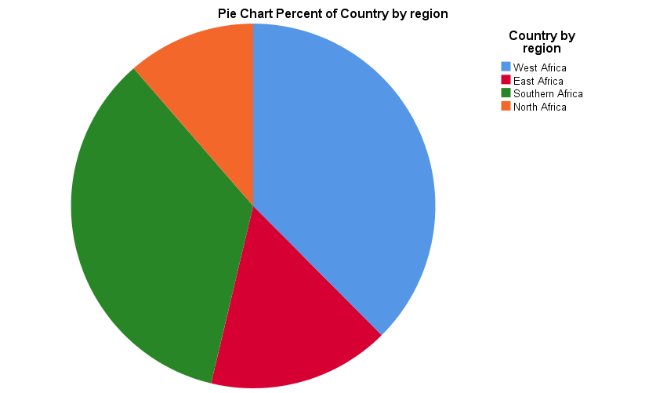
Figure 1. Pie chart percent of country per region.

As noted in the pie chart above, the highest share of country by region in the Afrobarometer sample was West Africa (n= 3874, 37.5%), followed by Southern Africa (n=3601, 34.9%), East Africa (n=1669, 16.2%) and North Africa (n=1175, 11.4%). Based on the results, it can be inferred that the largest sample came from West Africa, compared to parts of the region such as East Africa and North Africa.
The results analyzed suggest a higher sample size was sourced from West Africa, suggesting social change empowering individuals to participate in the project was rampant, compared to Eastern and Northern Africa. Similarly, Southern Africa is another region where the population had received enough education and had knowledge and capabilities to participate in the survey, suggesting higher levels of social upliftment compared to East and North Africa.
From a regional perspective, it appears the population in the Western and Southern parts of Africa is more aware of changes in governance and democracy and more capable of participating in educational surveys.
Visual Display of Continuous Data
The histogram shows differences in percentage or frequency among categories of scale or ordinal variables (Frankfort-Nachmias et al., 2020). In the Afrobarometer, histogram of Trust in Government Index (TRUSGOVT) was prepared to show the index score with higher scores indicating more trust. In a bar graph, the spaces interspersing the bars are used to indicate the separation between categories. However, a histogram indicates intervals are ordered from low to high in a meaningful way (Frankfort-Nachmias et al., 2020).

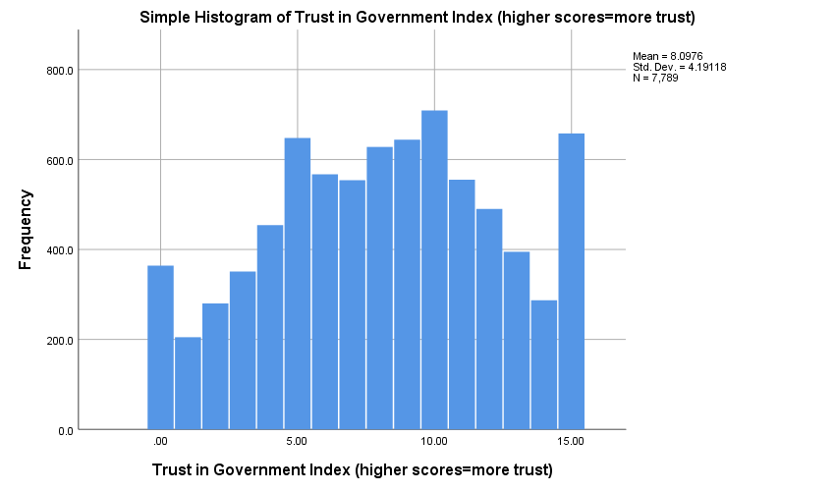
Figure 2. Histogram of Trust in Government Index

As can be inferred, the mean score is 8.0976(SD=4.19). The scores ranged from 0 to 15.A total of 364 (3.5%) of the respondents scored 0. A score of 1 was assigned by 205 individuals or 2.0%. Furthermore, 280 individuals (2.7%) assigned a score of 2 while 351 (3.4%) assigned a score of 3. A total of 454 individuals (4.4%)allocated a score of 4. The third highest number of respondents in the sample (n=648, 6.3%) with a score of 5, while 567 (5.5%) assigned a score of 6.
A total of 554 individuals (5.4%) assigned a score of 7, while 628 (6.1%) gave a score of 8. The fourth highest number of participants in the sample thus assigned the average mean score. Another 644 individuals (6.2%) gave a score of 9, while 555 individuals (5.4%) were assigning a score of 11, and 709 individuals or 6.9%of the sample assigned a score of 10. Most participants in the sample, therefore, assigned a score of 10. Around 490 individuals (4.7%) provided a score of 12, while 395 respondents (3.8%) accorded a score of 13. An additional 287 (2.8%) scored 14 while 658 (6.4%) constituted those assigning a score of 15.
Therefore, while a majority of the respondents gave a score of 10, the second highest number of respondents gave a score of 15 while the third highest set of respondents assigned a score of 5. A high number of participants scored an average value of 8, and the entire sample scored a mean score of 8.09, suggesting moderate levels of trust in the government. This has implications for social change, as most participants did not score high on trust in the government suggesting social and political factors at play in impacting the perceptions of governance among African participants. Therefore, visual displays for continuous and categorical variables differ on account of the nature of the data. Rules for data display must aid in comprehensibility of information (Walden University Writing Center, n. d).
Conclusion
Therefore, the graphical means of representation yielded important insights for survey researchers and the wider academic community. While nominal, categorical variables such as region of the country had important implications for inferring level of participation in academic research and, by implication, how educated or active the region was in commenting on such matters and impacting levels of social change. Secondly, the continuous variable, trust in government index, was an important indicator of how social perceptions were involved in understanding and assessing the quality of governance in Africa. Graphical displays such as pie charts and histograms make it easier to compare data and draw inferences of value to the entire scientific community.
References
Frankfort-Nachmias, C., Leon-Guerrero, A., & Davis, G. (2020). Social statistics for a diverse society (9th ed.). Sage Publications.
Dietz, T., & Kalof, L. (2009). Introduction to social statistics: The logic of statistical reasoning. Wiley-Blackwell.
Wagner, III, W. E. (2020). Using IBM® SPSS® statistics for research methods and social science statistics (7th ed.). Sage Publications.
Walden University Writing Center. (n.d.). General guidance on data displays. Retrieved from http://waldenwritingcenter.blogspot.com/2013/02/general-guidance-on-data-displays.html

