Week 2 Assignment

Student’s Name
Department and University
Course Number and Name
Tutor’s Name
Due Date

Week 2 Assignment

The bar graph presents ordinal or nominal data effectively (Frankfort-Nachmias et al., 2020). Patterns of data can be analyzed utilizing such visual displays (Dietz & Kalof, 2009). The present paper seeks to justify and present a visual display from the GSS (General Social Survey) dataset for ascertaining the role of graphical displays in answering questions about social change and making choices regarding appropriate visual displays for data.
Mean of Age
Table 1

Mean Age of Respondent

AGE OF RESPONDENT
N | Valid | 508
 | Missing | 2
Mean |  | 48.62

In table 1 above, the mean age of the participants was 48.62 years.
Bar Graph Visual Display
The bar graph is ideal for displaying differences in frequencies and percentages of nominal or ordinal variables (Frankfort-Nachmias et al., 2020). In the present study, gender and educational status were the variables utilized to create the visual display of the bar graph. The categories are displayed as rectangles of frequent width with height proportional to frequency or percentage of the particular categories (Frankfort-Nachmias et al., 2020). According to Wagner III (2020) standard as well as clustered or stacked bar graphs can be produced in SPSS. The following constitutes a table and a clustered or stacked bar graph showing the interaction of gender and educational degree from the General Social Survey Dataset:
Table 2

Highest degree x Respondent’s Sex (Frequency Distribution)

RS HIGHEST DEGREE * RESPONDENTS SEX Cross tabulation
 |  | RESPONDENTS SEX |  | Total
 |  | MALE | FEMALE
RS HIGHEST DEGREE | LT HIGH SCHOOL | 24 | 42 | 66
 | HIGH SCHOOL | 128 | 150 | 278
 | JUNIOR COLLEGE | 19 | 30 | 49
 | BACHELOR | 44 | 36 | 80
 | GRADUATE | 15 | 22 | 37
Total |  | 230 | 280 | 510

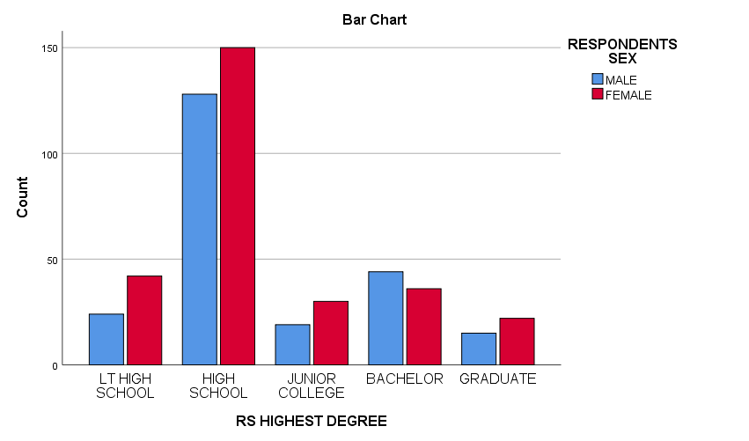

Therefore, the visual display above has implications for social change, as the bar graph demonstrates male respondents have fewer educational qualifications compared to females at lower levels while at the bachelor’s degree level, higher number of males have a degree while the trend reverses for junior college and graduates suggesting women empowerment through education is recording a positive change in recent times, as per the General Social Survey Dataset.
Therefore, this bar graph compared categories of the variable across different groups (Male versus Female). A significant advantage of this bar graph based visual display is that it permits side to side comparison visually and shows categories of variables arrayed in such a way that frequencies or percentages can be compared (Frankfort-Nachmias et al., 2020). As per Fischer et al. (2005), such graphs are a common means of communicating to convey information or support exploration of specific datasets. Spatial congruency between graphical and textual data is also assured (Fischer et al., 2005). Easy comprehensibility and spatial compatibility for lateralized button responses are some of the advantages of the vertical bar graph (Fischer et al., 2005).
Conclusion
In drawing up solutions to important social change questions, bar graphs are particular useful because even smaller changes in values across different variables, groups or categories are possible using this visual display. Bar graphs remain a suitable medium for visualizing and supporting the reading of exact values and key differences, as well as concrete contrasts within the data. Vertical bar graphs in particular are easy to read and use. This remains the enduring contribution of this visual display to research focused on scientific and quantitative reasoning.

References
Fischer, M. H., Dewulf, N., & Hill, R. L. (2005). Designing bar graphs: Orientation matters. Applied Cognitive Psychology: The Official Journal of the Society for Applied Research in Memory and Cognition, 19(7), 953-962.
Frankfort-Nachmias, C., Leon-Guerrero, A., & Davis, G. (2020). Social statistics for a diverse society (9th ed.). Sage Publications.
Dietz, T., & Kalof, L. (2009). Introduction to social statistics: The logic of statistical reasoning. Wiley-Blackwell.
Wagner, III, W. E. (2020). Using IBM® SPSS® statistics for research methods and social science statistics (7th ed.). Sage Publications.

